附件2：清新区历史遗留矿山遥感影像图截图
ZJ4418032025001001
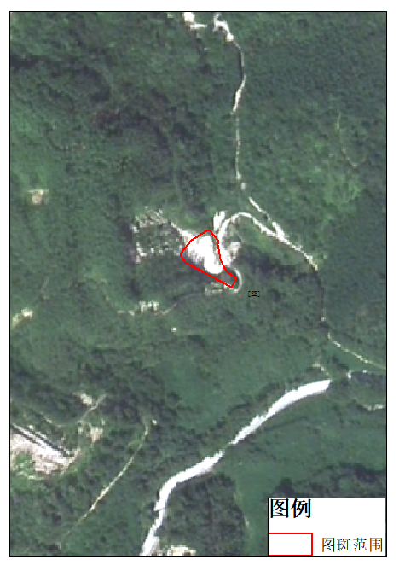
ZJ4418032025001002
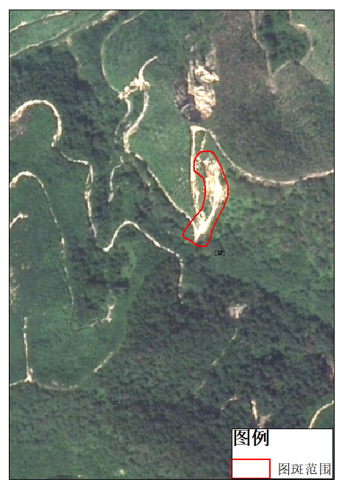

ZJ4418032025001003
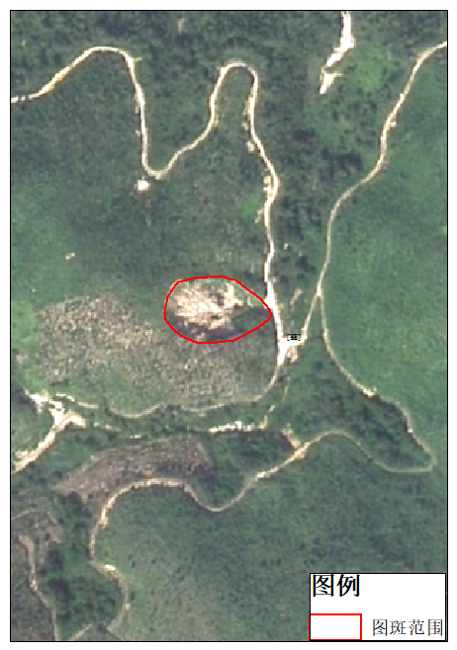
ZJ4418032025001004
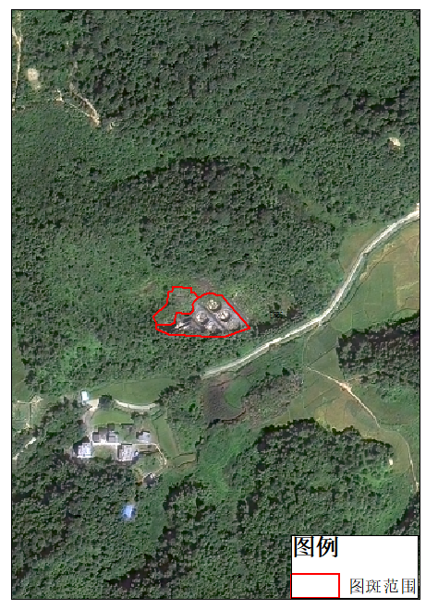

ZJ4418032025001005
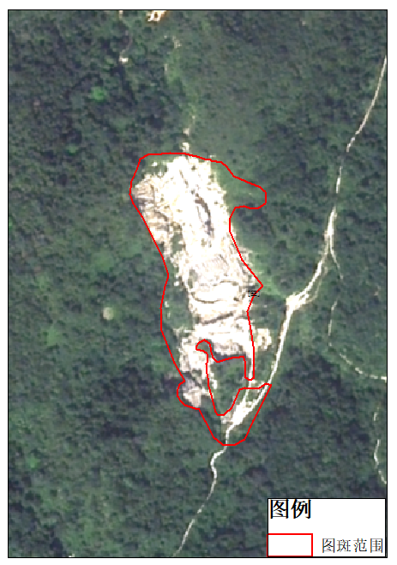
ZJ4418032025001006
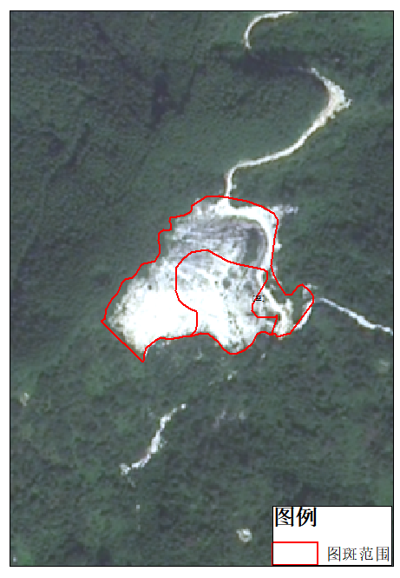

ZJ4418032025001007
ZJ4418032025001008

